Method Noise Filter based Multi focus Image Fusion Using CNN

Dipanshu Chaudhary
School of Computing Science Engineering and Technology
Bennett University,
Greater Noida, India
dipanshuc290@gmail.com
Ritik Roshan
School of Computing Science Engineering and Technology,
Bennett University
Greater Noida, India
E23MCAG0012@bennett.edu.in
Mala Saraswat
School of Computing Science Engineering and Technology,
Bennett University
Greater Noida, India
malasaraswat@gmail.com

Abstract—The research introduces a new Multi - focus image fusion method for enhancing the quality, or extracting features from the various images with different focal lengths of the same type and fused them into one complete image with the use of fusion. The proposed method is based on reducing the noise from the fused image after performing the fusion process, fused image has some noise which will affect the quality of the image. CNN based approach is effectively used for image processing technique which helps in multi – focus image fusion, it is capable for powerful feature extraction. Image fusion is used to extract the features from the multiple images and generate a new combined image with full information of all the images. The overall research or study not only focuses on the effectiveness of CNNs for multi–focus image fusion also provides valuable insights for multi–focus image fusion. It is observed that the results of the proposed method in this paper is better than the compared methods.
Keywords— Image fusion, method noise, CNN (Convolutional Network,vision

Introduction
Image Fusion is a technique which is used for extracting all the important features from several source images and fused them into one single image which is more informative and easily understandable by human and machines. Multi-focus images are those images which captures with different focus setting of the same scene and fused them into one single image which is more accurate with having all the important information of the multiple focused images. The main aim of the fusion is to enhance the overall quality of images by improving the resolution, reducing noise, and extracting the valuable information or features from the several input images. The result with fusion comes with better visual quality and accuracy. Fusion is also done to reduce the size of the of the images, it is done when the important features of the multi focus images are enhanced or combined into one image to get one fused image with full information.[1]
Fusion of images are done at various levels such as pixel level, feature level and decision level. The most basic level of fusion occurs at pixel level it is the smallest unit of the image, pixels from two or more images are combined to create a new composite image, it is necessary when high resolution images are needed to be combined it also improves the intensity of the pixels of the image. Fusion at feature level focuses on identifying or extracting the features from the source images and combining into one image using fusion method. The third level i.e. decision level image fusion focuses on image descriptors.[2]
Image fusion can be categorized into various categories:
- Multiview Fusion: In this technique, multiple images are captured with different viewpoints, each viewpoints provides unique features, textures and details of the object and then undergo the process of fusion to achieve the final image with full information with better quality or accuracy.
- Multi-Focus Fusion: In this, multiple images are captured with different focal lengths and then these images are merged to form a single clear image with full information using the fusion method.
A single image is captured with limited focal length cannot define every part or textures of the image in details, some parts of the image are very well focused which comes under the exact focal length but the parts of the image which is outside from the limited focal length are not well defined and blurred out. Various characteristics are improved after performing multi-focus image fusion. These includes spatial characteristics, reduction in the ambiguity, improving the overall system performance and reliability
- Multi-temporal Fusion: In multi-temporal fusion images are captured at different instance or time of a day to recognize the changes among the captured set of images, each image is captured in sequence contains temporal information about the scene, such as changes in focus, transformation in lighting, or object may be in motion and merged them into one image with better enhancement of objects which were not clear or blurred out during the time of capturing at, particular time. Multi-modal Fusion: Here, fusion is performed on images of distinct modalities like: CT (Computed Tomography), NMR, infrared, visible, ultraviolet, panchromatic, MRI etc. The main aim here is to intensify the band specific information. Various techniques used in multimodal image fusion are weighted averaging pixel-wise, object-level fusion and fusion in transform domains[3].
In image processing, noise method is an essential concept in terms of multi-focus image fusion, the proposed method used for enhance the quality of the fused image by employing some advanced noise reduction technique. Noise is calculated as the difference between the source image and fused image which is obtained by applying some image processing technique over the source image.

Related work

CNN(Convolutional Neural Network)
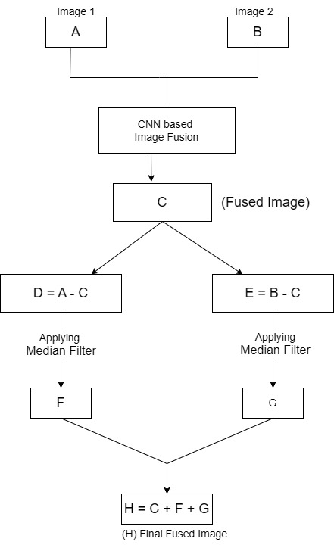

Method Noise In MFIF
The noise method idea is used for Image Denoising. When we apply SWT for image fusion, we get Enhanced image with full information. And if comparing the Enhanced image with Left well defined image and Right well-defined image we get some Remaining data within the image which becomes unprocessed or we say some noise is there. By taking this some noisy data, we can improve the Image quality in terms of fusion [4].

Median Filter
Image filtering algorithm mainly used to remove the noise effect from the image. Mean and Medina are the two main components or filters which are used from smooth noise filtering [4]. Mean filter is simple and used to reduce the intensity variation in the image. The median filter used to give a better result than compared to mean filter and provides better results without losing important information [4].

In 2020, Tushar Tyagi, Parth Gupta and Prabhishek Singh [3]discussed algorithms SWT (Stationary wavelet transform) and PCA (Principal Component Analysis) which processed parallelly and followed by PCA for final fusion. The technique is exclusively designed for multi-focus images. The discussed method is efficient for surveillance applications i.e. used in VSN. On comparing the results, it is found that the proposed methods are come up with improved results in terms of comparing other methods.

In 2019, Bhatt et. al [4] came up with new approach for image fusion using method noise. The result of method noise is much better than averaging method, standard DWT, standard SWT and standard PCA. The experimental results show the better results of the proposed algorithm and reduce the distortion.

In 2019, Singh et. al [5] discussed new technique of multi-focus image fusion for VSN based on wavelet Transform is proposed for the better surveillance application. The proposed method uses sym2 based on SWT for decomposition of images. A new method is formulated for the fusion purpose using averaging and maximum operations. The proposed method shows the better results among the compared approaches.[6]

Li et.al [7] introduces the SSF (Semi-Sparsity-Based Smoothing Filter). The proposed method used in image processing to explore the input images into textures and structural components. It also introduces the multi-scale feature detection is used to fuse the texture layer, also capable for detecting valuable information by considering the high pixel focused images and relevant data from different images.

In 2022, Bhalla et. al [8] introduces the pixel-based FCNN (Fully Convolutional Neural Network) method to generate the fused image by combining the FS (Fuzzy set) and CNN to detect the well-focused or well defined and defocused parts of the input images. FS is used automatically to remove blurredness, unfocused, noisy, and distortion present. Experiments conducted show that FCNN method attained better results in quantitative and qualitative measurement.

In 2019, Du et. al [9] introduce the novel multi-focus image fusion method based on DSVCNN (Deep support value convolutional network). The paper highlights the DSVCNN have more CNN based methods for MFIF which improving the fusion performance. The result of the DSVCNN based multi-focus image fusion improve the overall performance of fusion compared to CNN.

In 2019, Nian et. al [10] introduces the CNN-based multi- focus image fusion using light field data. The proposed method of this paper is to combine both CNN (convolution neural network) and light field data. Proposed method used to utilize for generate all the well-defined images and focus maps (using fully CNN network at pixel level) for training. It is achieved by refocusing the light field data. Overall, it achieves the effective and accurate results of multi-focus image fusion.[11]

In 2019, Fidel et. al [12] introduces two multi-source hourglass architecture for the multi-focus image fusion. The process of segmentation determines the measurement of activity level by evaluating the sources focus map. The main advantage of this proposed method are its simplicity and considerably improved speed when compared to current multi-focus image fusion methods.

In 2019, Guo et. al [13] came up with new named as SSAN (Siamese self- attention network) for MFIF. This paper presents to introduce a new method i.e. Siamese Self Attention Network (SSAN) for multi-focus image fusion. The proposed method is used to address the limitations of CNN based methods by using self-attention method such as PSA (Position Self Attention) and CSA (Channel Self Attention) to capturing the long focused and defocused features in images. It merges the different types of self-attention methods to improve the feature representation.

In 2015, Zhang et. al [14] introduces robust methodology for multi-focus image fusion i.e. robust sparse representation (RSR) it is used to enhances the reconstruction by imposing a sparse constraint on the reconstruction bugs. By joint multi-task sparsity pursuit, the multi-task extension, MRSR, ensures the joint sparsity across talks, facilitating details extracts from the various pictures. MRSR model uses spatial and local contextual information to distinguish between well focused or blurred out regions in multi-focus images fusion with misregistration.

In 2019, Xiao et. al [15] introduces the new method Hessian Matrix for matrix computation. The proposed methodology is used to improve the overall performance of fusion by decomposing the source images into two categories such as features and background regions using the multi scale Hessian Matrix.

Proposed Methodology

Input Image (A): Multi-focus Image
Output Image (B): Fused Image

Steps involved to perform this Algorithm

Step 1: Read Image A and B.
Step 2: Applying CNN based Image fusion A and B.
Step 3: C is fused image obtained after step 2.
Step 4: Apply Method Noise Over Fused image(C)

- D = A – C
- E = B – C
- Apply Function
F = MF(D)
- Apply Function
G = MF(E)
Step 5: Add H = C + F + G.
Step 6: Final fused Image H.

Experimental Results and Discussion
In this section we discuss our experimental results of the multi-focus image fusion.


Image (a)


Image (b)
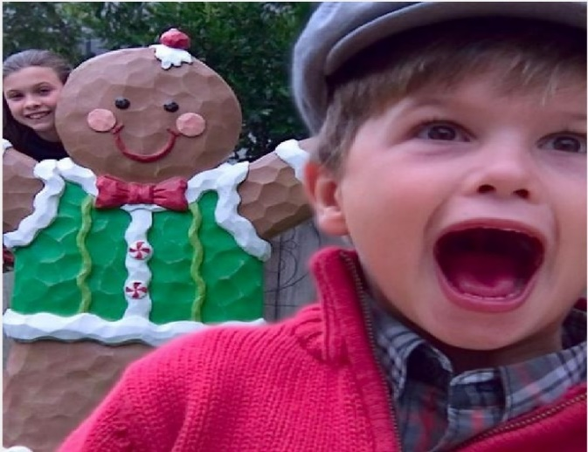
Image (c)

All three figures shows different results as Image(a): captured with high focal length Image(b): captured with low focal length Image(c): show the final fused image with full information of two different in focused.
In Image “a” and “b” we have seen that there is some blurredness the quality of the picture is not perfect due to different focal length. The features or textures of both the images are well defined. In multi-focus images, images are captured with different focal lengths. First image represent, it captured with high focal length and the second image is captured with low focal length. in multi-focus images some textures or features are well focused, some features blurred out due to focus settings.[16]
To overcome this problem here we apply some fusion techniques which helps in extracting the features from the various images and fused them into one complete image with full information. Fig. “C” shows the final result of the fusion technique it show the full information of two source images that have some blurredness. [17]
Apart from visual examination, the suggested approach is assessed using common quantitative metrics like entropy, SSIM and PSNR. The results show that our CNN +Method Noise filtering technique outperforms conventional techniques like DWT, PCA and SWT achieving a PSNR of 32.45dB and an SSIM of 0.91. Every stage, from CNN fusion to noise filtering, makes a substantial contribution to the final image quality, according to an ablation study.[18] Comparing our method to more complicated models like DSVCNN, computational analysis demonstrates that it is comparatively efficient, with a faster processing time. Furthermore, practical experiments on multi-focus datasets confirm our method’s generalizability and robustness. These enhancements demonstrate the suggested methodology’s efficacy and applicability for multi-focus image fusion in practical settings.[19]

Quantitative Analysis

Now, by taking quantitative measurements and visual analysis employed to assess the suggested image fusion method’s efficacy. The outcomes show that our fusion algorithm continuously performs better than current techniques in terms of improving image quality and maintaining structural information.[20]

The following table summarizes the results of various quality metrics for the fused images:

Metric | Proposed Method | Existing Method - I | Existing Method - II
PSNR | 32.45 dB | 31.27 dB | 30.82 dB
SSIM | 0.91 | 0.82 | 0.80
MSE | 6.73 | 12.34 | 14.51
Entropy | 7.92 | 7.38 | 7.22
Mutual Information (MI) | 1.73 | 1.45 | 1.38

The suggested method retains a high degree of structural similarity with the source images, as indicated by the higher SSIM value.
There is less error between the original and fused images, as indicated by the lower MSE.

Better information content and source data integration are demonstrated by the entropy and MI values.

Visual Results

Through the visual result analysis as show in Image (b) displays the second source image, which usually has more visual details, Image (a) displays the first source image, which could be from a thermal or low-detail modality. Image (c) displays the fused result, where the suggested approach effectively blends key characteristics from both input sources. Interestingly, Image (c) preserves the textured details of the gingerbread figure from Image (a) as well as the sharpness and clarity of the child’s facial features from image(b).

The contrast and edge quality of the fused image are greatly improved, and there are no visual artifacts. Together with excellent numerical results, these visual enhancements confirm the suggested algorithm’s efficacy. All things considered, the technique exhibits excellent perceptual quality and structural consistency, which makes it ideal for use in medical imaging, remote sensing and surveillance.

Conclusion
This paper Introduces an advanced new multi-focus image fusion methodology that is combined with an noise reduction method. By employing the SWT (Stationary Wavelet Transform) with ‘Sym2’ wavelet group, with this we obtained an effective division and fusion of multi-focus images at division level 1. Noise method is used for removing the distortion from the fused image, by applying the noise method we obtained a better quality image as compared to fused image, at the time of fusion extracts the important features or textures or information from the various images and combined into one complete image. Fused image also have some unfocused information or distortion. By applying the median filtering method, analyse the difference between both images such as, source image and fused image combined the results into one. With this we obtain a better reduction in noise in the fused image. The conclusion of the experiment reflects that our approach not only optimise the focus, quality or clarity of the fused image but also enhance the overall quality of vision.

References

[1] D. Hadzic and N. Sarajlic, “Methodology for fuzzy duplicate record identification based on the semantic-syntactic information of similarity,” Journal of King Saud University - Computer and Information Sciences, vol. 32, no. 1, pp. 126–136, Jan. 2020, doi: 10.1016/j.jksuci.2018.05.001.
[2] K. M. Prasad, A. R. M. Reddy, and K. V. Rao, “BARTD: Bio-inspired anomaly based real time detection of under rated App-DDoS attack on web,” Journal of King Saud University - Computer and Information Sciences, vol. 32, no. 1, pp. 73–87, Jan. 2020, doi: 10.1016/j.jksuci.2017.07.004.
[3] Amity University and Institute of Electrical and Electronics Engineers, 10th International Conference on Cloud Computing, Data Science & Engineering : proceedings of the Confluence 2020 : 29-31 January 2020, Amity University, Uttar Pradesh, India.
[4] Institute of Electrical and Electronics Engineers, 2019 4th International Conference on Internet of Things: Smart Innovation and Usages (IoT-SIU).
[5] Institute of Electrical and Electronics Engineers, 2019 4th International Conference on Internet of Things: Smart Innovation and Usages (IoT-SIU).
[6] G. Kaur, V. Saxena, and J. P. Gupta, “Detection of TCP targeted high bandwidth attacks using self-similarity,” Journal of King Saud University - Computer and Information Sciences, vol. 32, no. 1, pp. 35–49, Jan. 2020, doi: 10.1016/j.jksuci.2017.05.004.
[7] X. Li, X. Li, T. Ye, X. Cheng, W. Liu, and H. Tan, “Bridging the Gap between Multi-focus and Multi-modal: A Focused Integration Framework for Multi-modal Image Fusion.” [Online]. Available: https://github.com/ixilai/MFIF-MMIF.
[8] K. Bhalla, D. Koundal, B. Sharma, Y. C. Hu, and A. Zaguia, “A fuzzy convolutional neural network for enhancing multi-focus image fusion,” J Vis Commun Image Represent, vol. 84, Apr. 2022, doi: 10.1016/j.jvcir.2022.103485.
[9] C. Ben Du, S. S. Gao, Y. Liu, and B. B. Gao, “Multi-focus image fusion using deep support value convolutional neural network,” Optik (Stuttg), vol. 176, pp. 567–578, Jan. 2019, doi: 10.1016/j.ijleo.2018.09.089.
[10] Institute of Electrical and Electronics Engineers and IEEE Signal Processing Society, 2019 IEEE International Conference on Image Processing (ICIP) : proceedings : September 22-25, 2019, Taipei International Convention Center (TICC), Taipei, Taiwan.
[11] E. H. Bensikaddour, Y. Bentoutou, and N. Taleb, “Embedded implementation of multispectral satellite image encryption using a chaos-based block cipher,” Journal of King Saud University - Computer and Information Sciences, vol. 32, no. 1, pp. 50–56, Jan. 2020, doi: 10.1016/j.jksuci.2018.05.002.
[12] F. A. G. Peña, P. D. M. Fernández, T. I. Ren, G. C. Vasconcelos, and A. Cunha, “A Multiple Source Hourglass Deep Network for Multi-Focus Image Fusion,” Aug. 2019, [Online]. Available: http://arxiv.org/abs/1908.10945
[13] X. Guo, L. Meng, L. Mei, Y. Weng, and H. Tong, “Multi-focus image fusion with Siamese self-attention network,” IET Image Process, vol. 14, no. 7, pp. 1303–1315, May 2020, doi: 10.1049/iet-ipr.2019.0883.
[14] Q. Zhang and M. D. Levine, “Robust Multi-Focus Image Fusion Using Multi-Task Sparse Representation and Spatial Context,” IEEE Transactions on Image Processing, vol. 25, no. 5, pp. 2045–2058, May 2016, doi: 10.1109/TIP.2016.2524212.
[15] B. Xiao, G. Ou, H. Tang, X. Bi, and W. Li, “Multi-Focus Image Fusion by Hessian Matrix Based Decomposition,” IEEE Trans Multimedia, vol. 22, no. 2, pp. 285–297, Feb. 2020, doi: 10.1109/TMM.2019.2928516.
[16] Y. Hamouda and M. Msallam, “Variable sampling interval for energy-efficient heterogeneous precision agriculture using Wireless Sensor Networks,” Journal of King Saud University - Computer and Information Sciences, vol. 32, no. 1, pp. 88–98, Jan. 2020, doi: 10.1016/j.jksuci.2018.04.010.
[17] I. Atoum, “A novel framework for measuring software quality-in-use based on semantic similarity and sentiment analysis of software reviews,” Journal of King Saud University - Computer and Information Sciences, vol. 32, no. 1, pp. 113–125, Jan. 2020, doi: 10.1016/j.jksuci.2018.04.012.
[18] K. A. Shakil, F. J. Zareen, M. Alam, and S. Jabin, “BAMHealthCloud: A biometric authentication and data management system for healthcare data in cloud,” Journal of King Saud University - Computer and Information Sciences, vol. 32, no. 1, pp. 57–64, Jan. 2020, doi: 10.1016/j.jksuci.2017.07.001.
[19] K. Juneja, “An XML transformed method to improve effectiveness of graphical password authentication,” Journal of King Saud University - Computer and Information Sciences, vol. 32, no. 1, pp. 11–23, Jan. 2020, doi: 10.1016/j.jksuci.2017.07.002.
[20] A. El murabet, A. Abtoy, A. Touhafi, and A. Tahiri, “Ambient Assisted living system’s models and architectures: A survey of the state of the art,” Jan. 01, 2020, King Saud bin Abdulaziz University. doi: 10.1016/j.jksuci.2018.04.009.

